Modules and Packages

A module in Python is a file containing Python code. It can define functions, classes, and variables and include runnable code. Modules allow you to organize and reuse code across different programs.

In modules we have 2 types of modules:

* User-defined modules
* Built-in modules

**Built-in modules :**

The modules that are already predefined in python

1.math

import math  
print("square root of a number",math.sqrt(25))

2.random

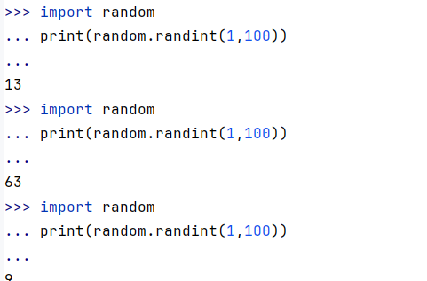

3.datetime

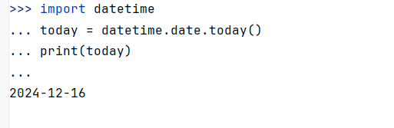

Importing the modules

